**CopyTest  
10/11/2020 16:42:31**  
User Is Navigated To Site : http://172.19.9.53/ICRARevamp/#/login  
  
*****CopyTest is Started *****  
Username is entered  
  
Password is entered  
  
Submit button is clicked  
Text of the element : Successfully logged in  
Successfully logged in  
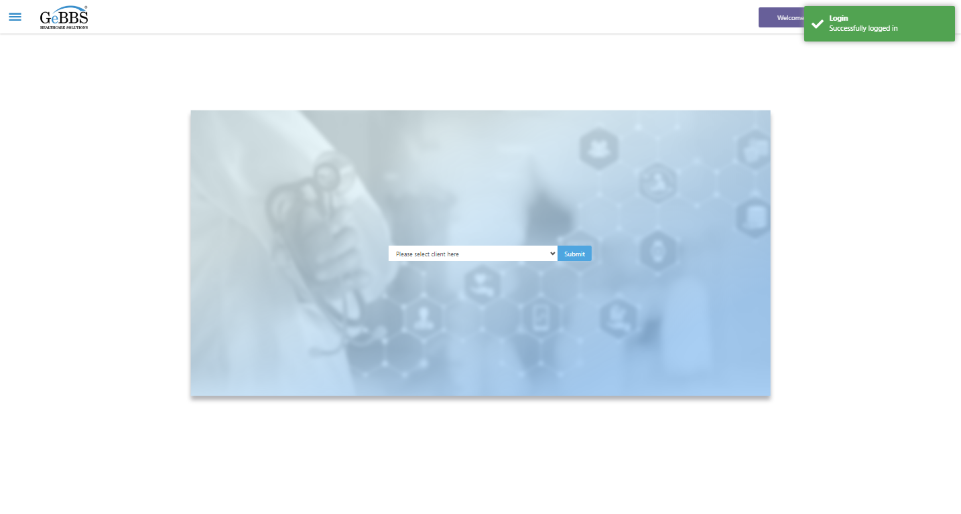  
Client dropdown button is clicked  
Client dropdown button is clicked  
Submit button is clicked  
Main Page loaded  
  
Scrolled successfully  
Chart Retrieval is clicked  
All submenus  
  
Submenu in 1 is :Field Tech  
Submenu in 2 is :FieldTech Area Assignment  
Submenu in 3 is :Intake  
Submenu in 4 is :RecordQA  
Submenu in 5 is :RecordQA Approval  
Scrolled successfully  
RecordQA is clicked  
RecordQA selected  
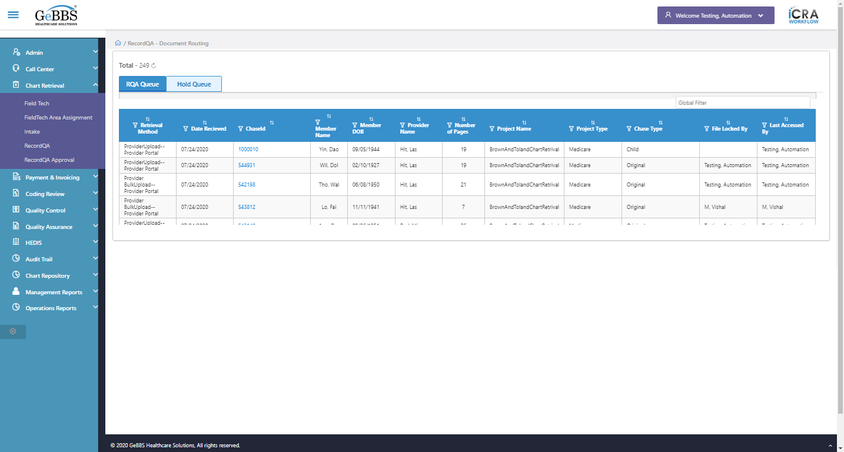  
 Retrieval Method is displayed  
  
text is correct  
  
1 th filter is displayed  
  
1 th sorting is displayed  
  
Sort is clicked  
1 th Asc-sorting is displayed  
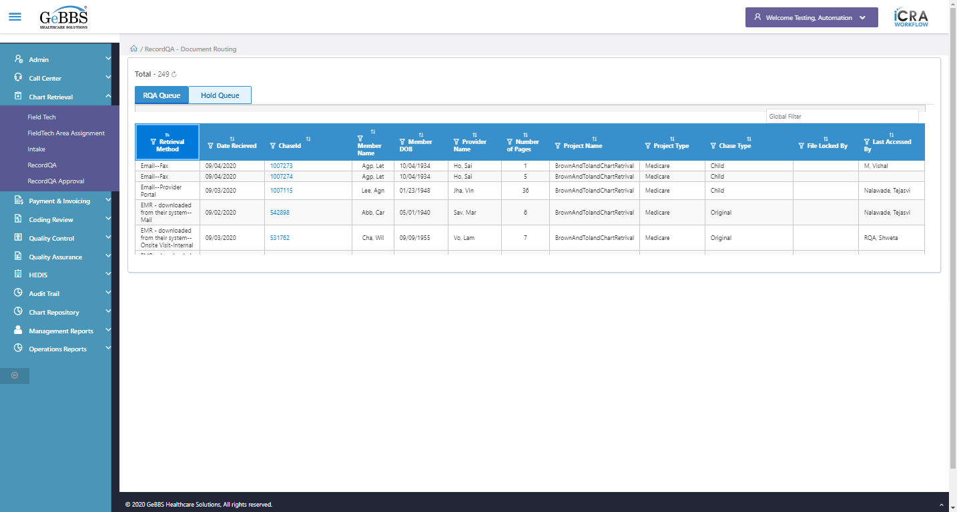  
Sort is clicked  
1 th dsc-sorting is displayed  
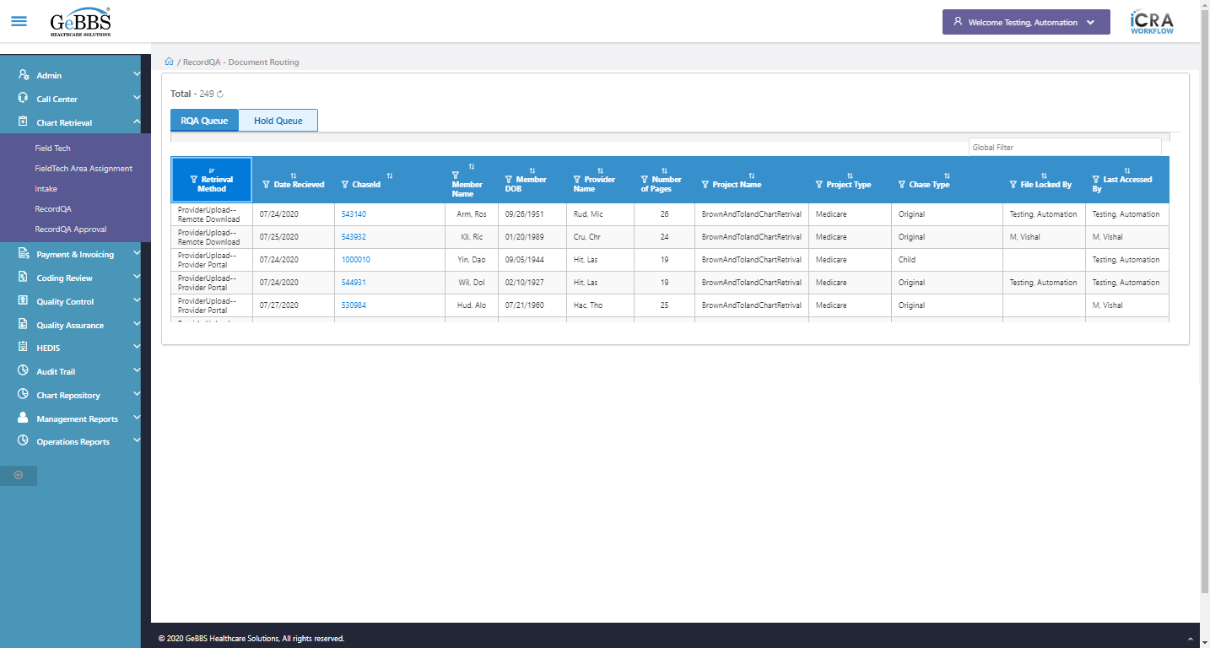  
 Date Recieved is displayed  
  
text is correct  
  
2 th filter is displayed  
  
2 th sorting is displayed  
  
Sort is clicked  
2 th Asc-sorting is displayed  
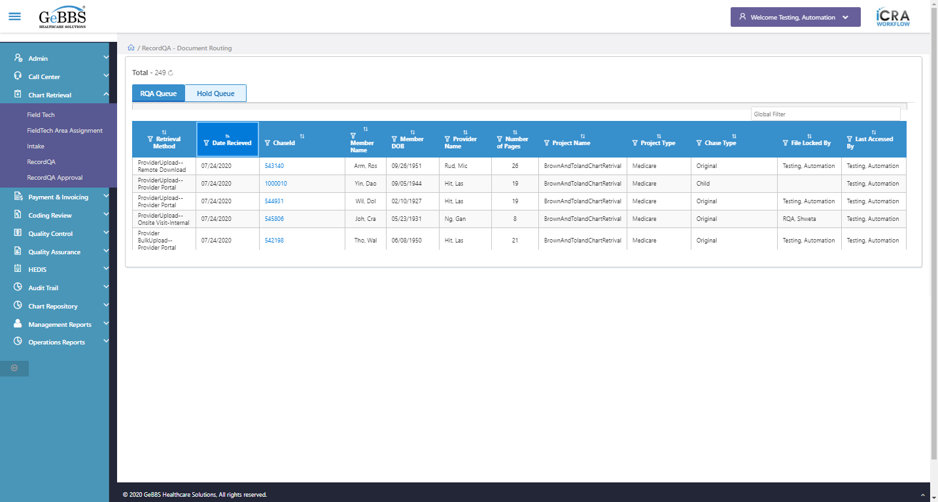  
Sort is clicked  
2 th dsc-sorting is displayed  
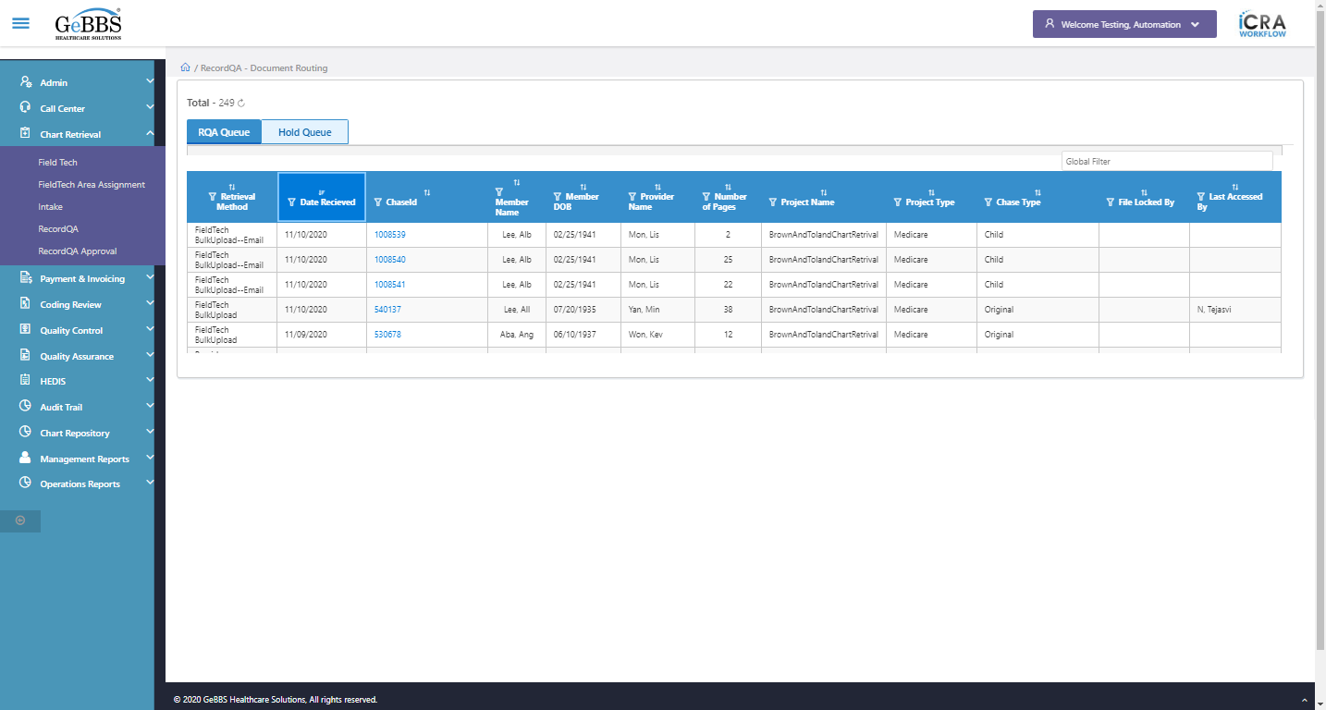  
 ChaseId is displayed  
  
text is correct  
  
3 th filter is displayed  
  
3 th sorting is displayed  
  
Sort is clicked  
3 th Asc-sorting is displayed  
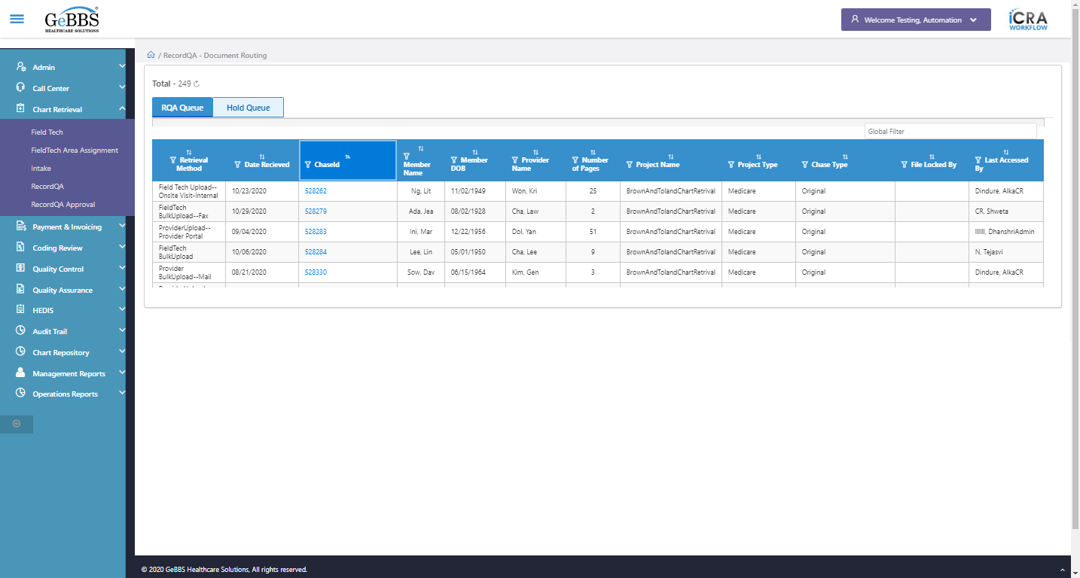  
Sort is clicked  
3 th dsc-sorting is displayed  
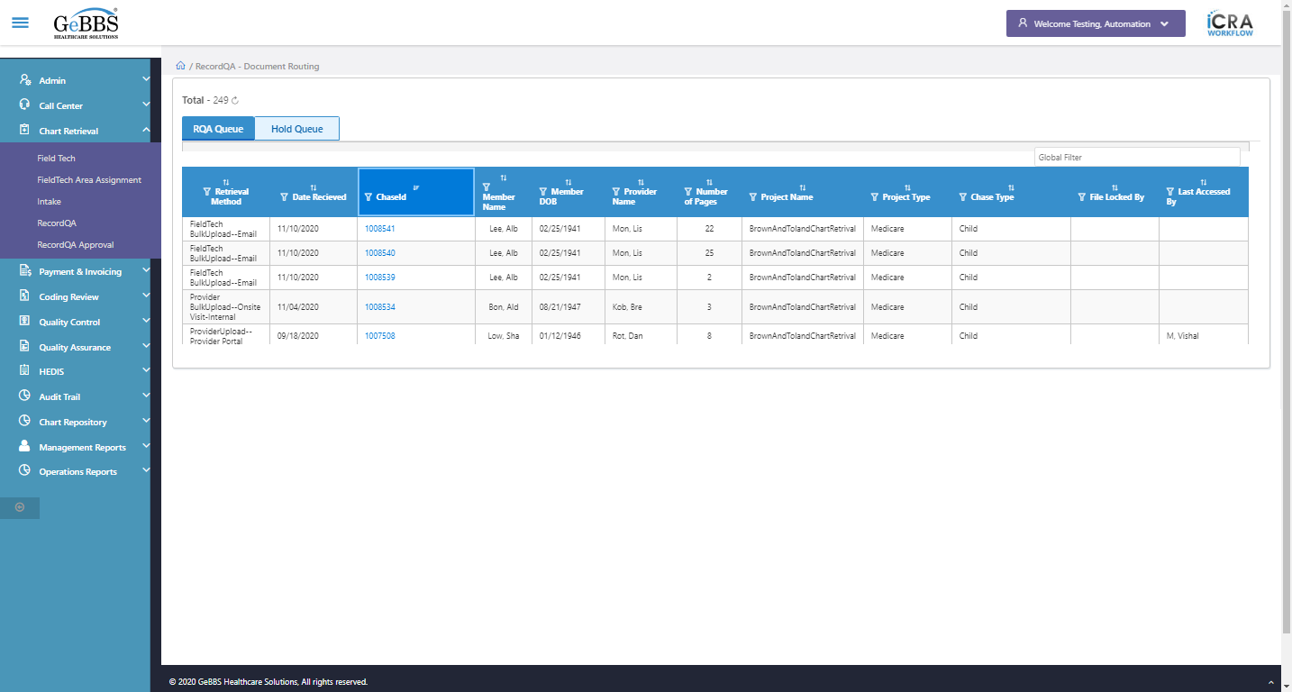  
 Member Name is displayed  
  
text is correct  
  
4 th filter is displayed  
  
4 th sorting is displayed  
  
Sort is clicked  
4 th Asc-sorting is displayed  
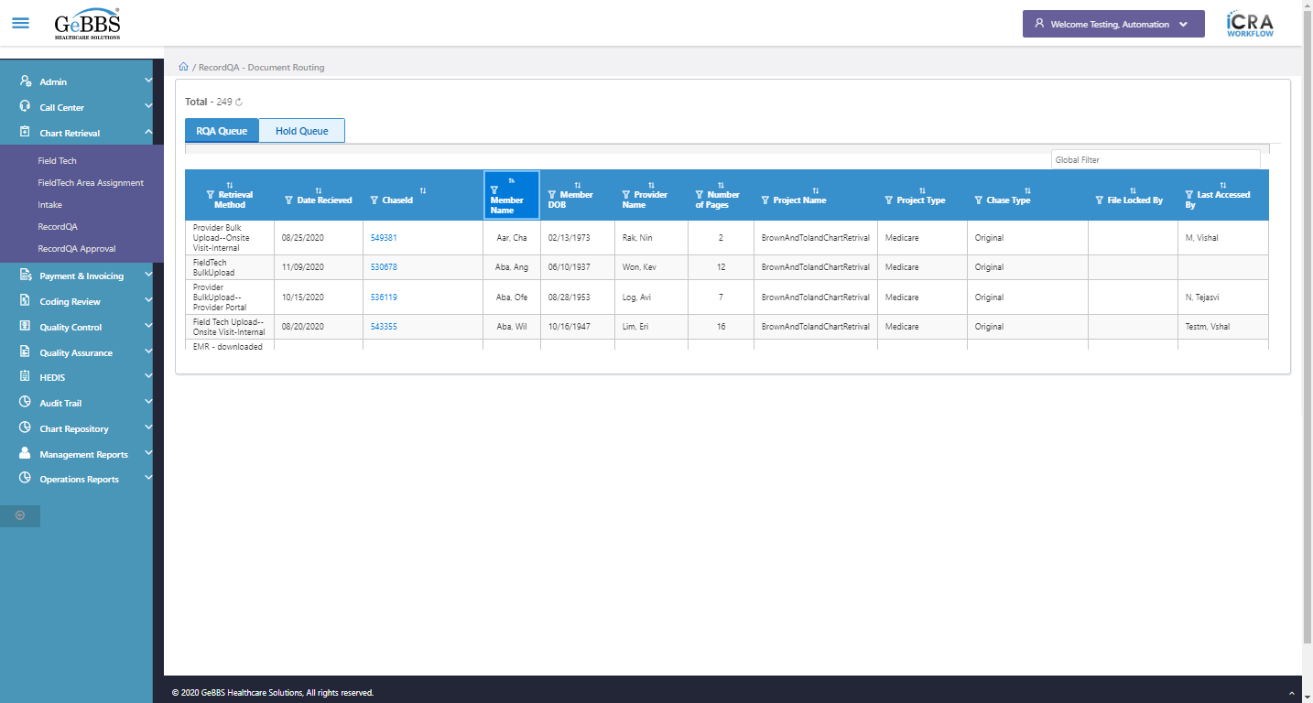  
Sort is clicked  
4 th dsc-sorting is displayed  
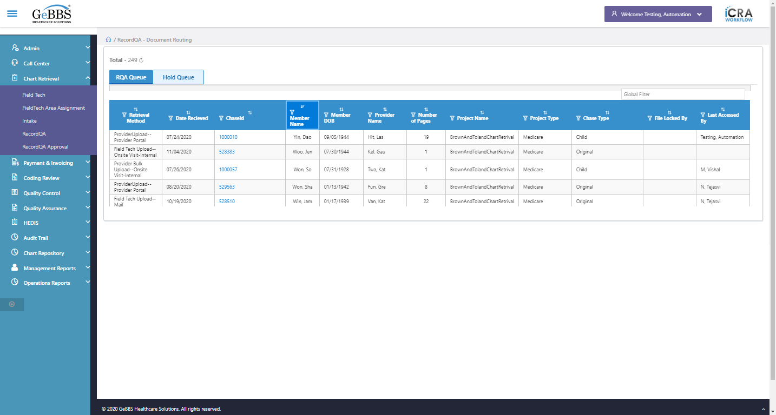  
 Member DOB is displayed  
  
text is correct  
  
5 th filter is displayed  
  
5 th sorting is displayed  
  
Sort is clicked  
5 th Asc-sorting is displayed  
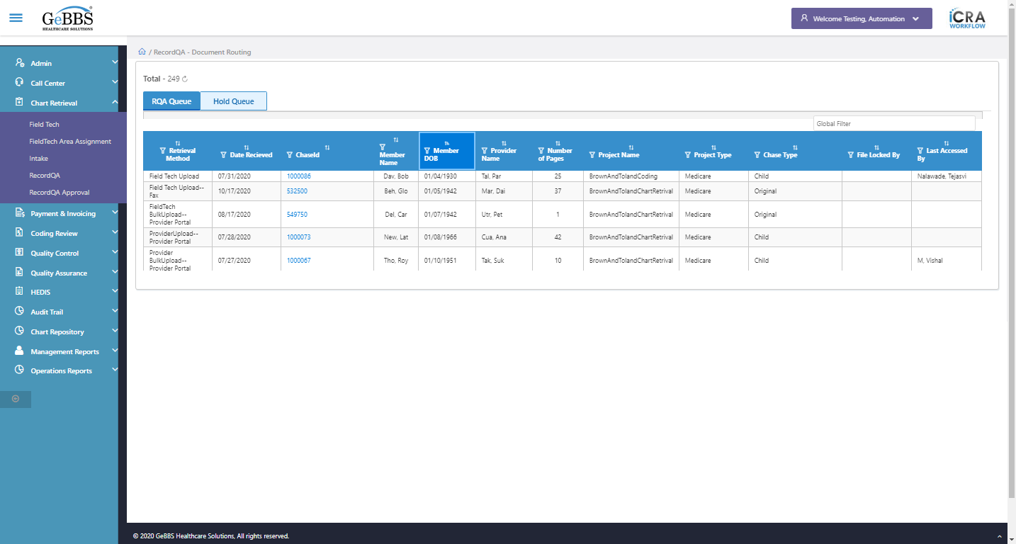  
Sort is clicked  
5 th dsc-sorting is displayed  
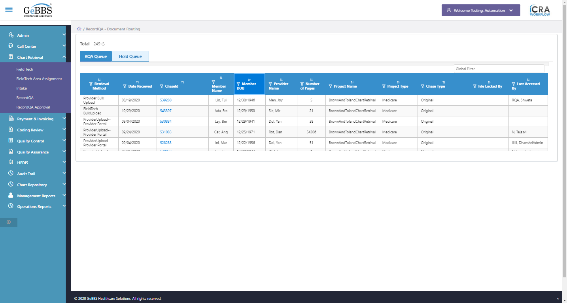  
 Provider Name is displayed  
  
text is correct  
  
6 th filter is displayed  
  
6 th sorting is displayed  
  
Sort is clicked  
6 th Asc-sorting is displayed  
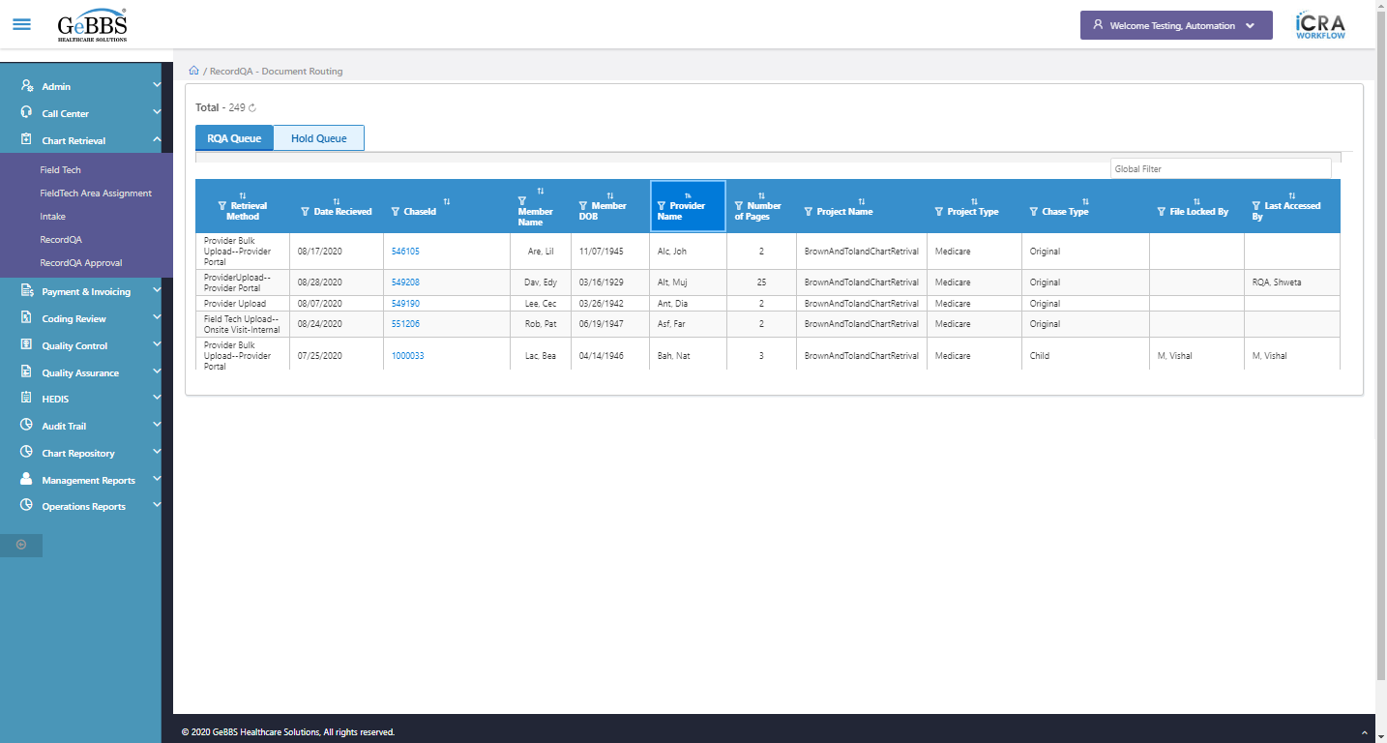  
Sort is clicked  
6 th dsc-sorting is displayed  
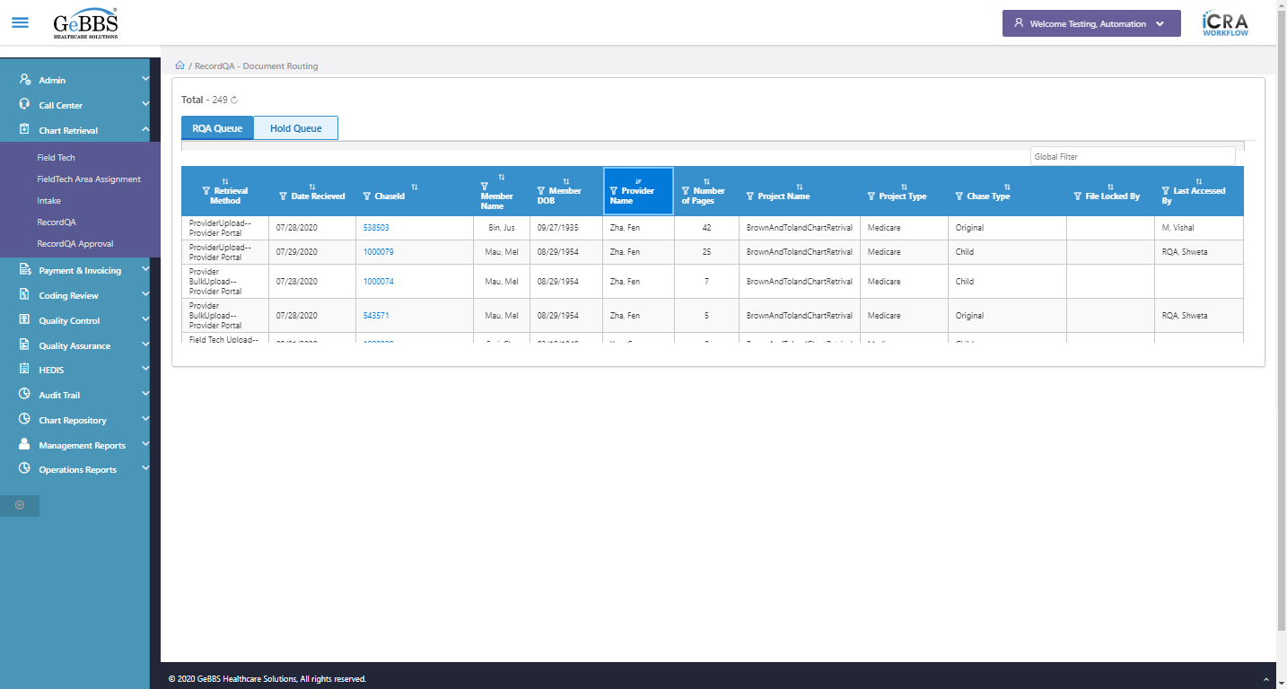  
 Number of Pages is displayed  
  
text is correct  
  
7 th filter is displayed  
  
7 th sorting is displayed  
  
Sort is clicked  
7 th Asc-sorting is displayed  
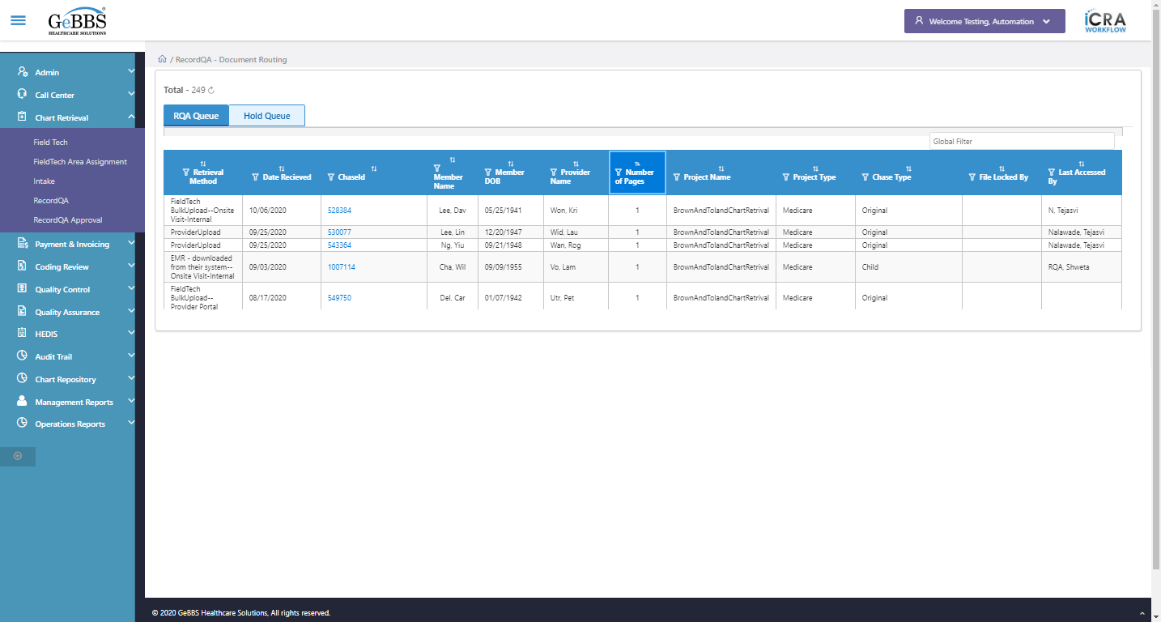  
Sort is clicked  
7 th dsc-sorting is displayed  
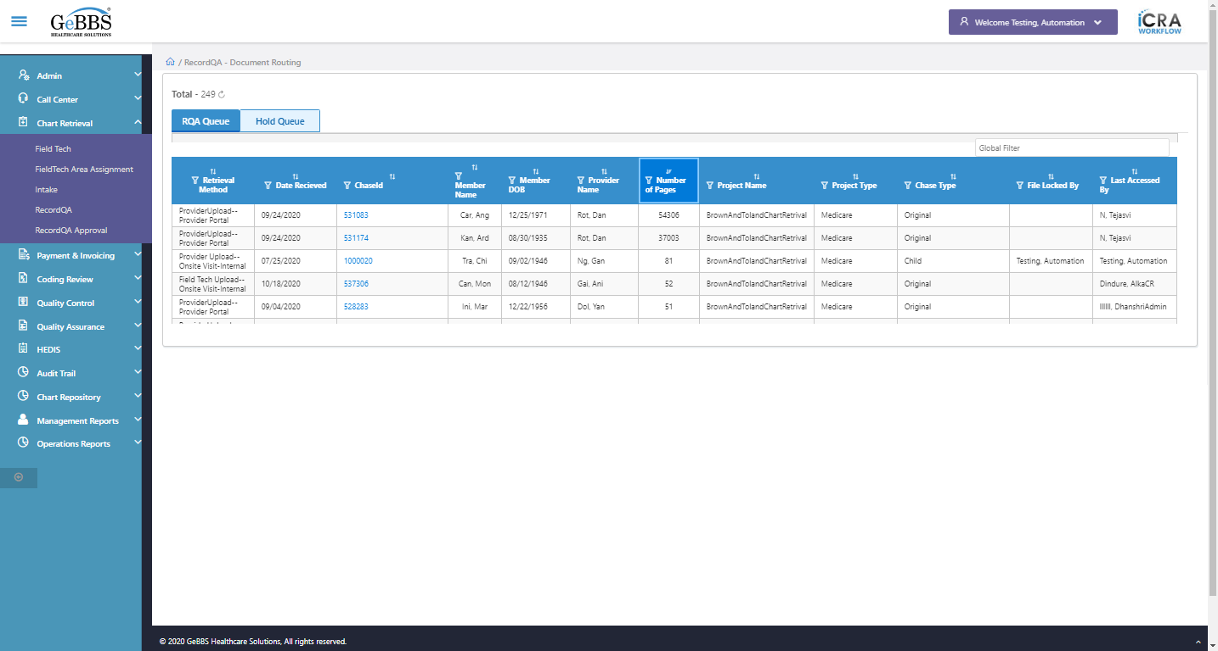  
 Project Name is displayed  
  
text is correct  
  
8 th filter is displayed  
  
8 th sorting is displayed  
  
Sort is clicked  
8 th Asc-sorting is displayed  
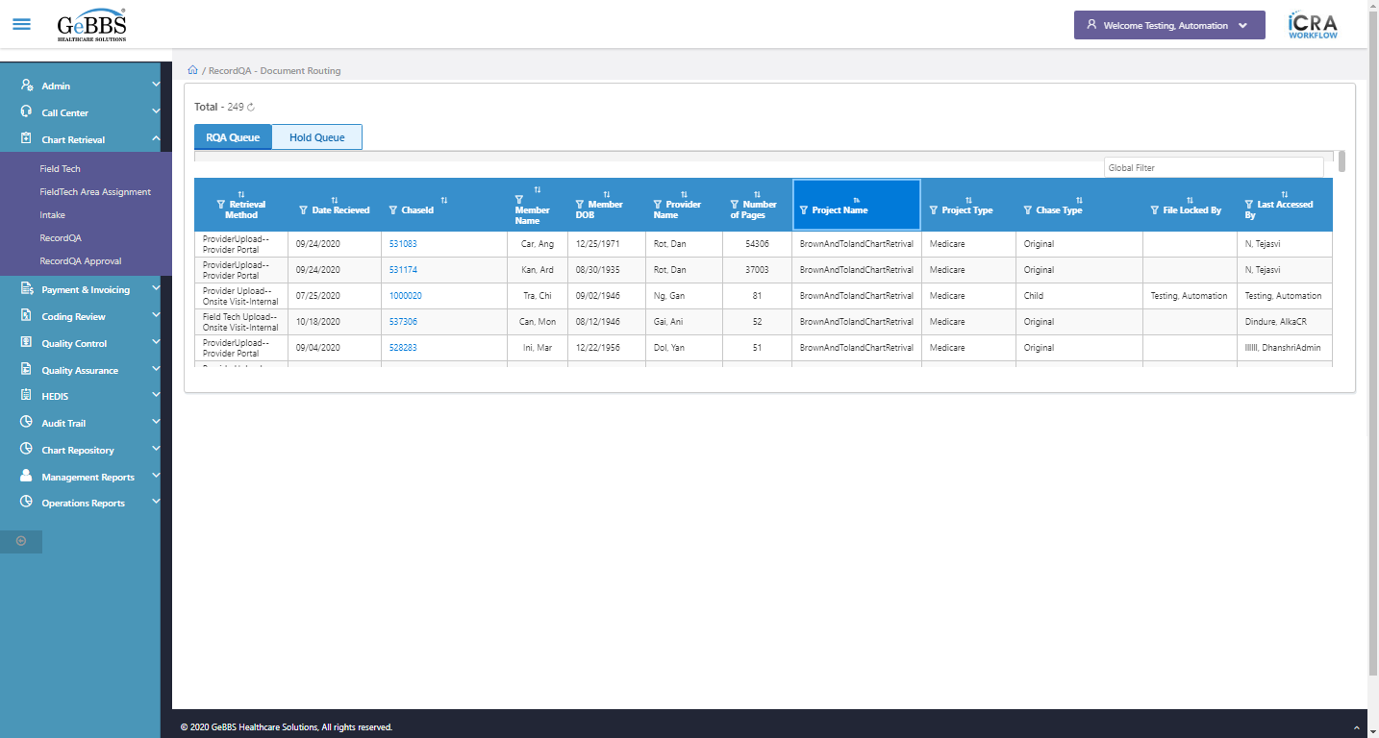  
Sort is clicked  
8 th dsc-sorting is displayed  
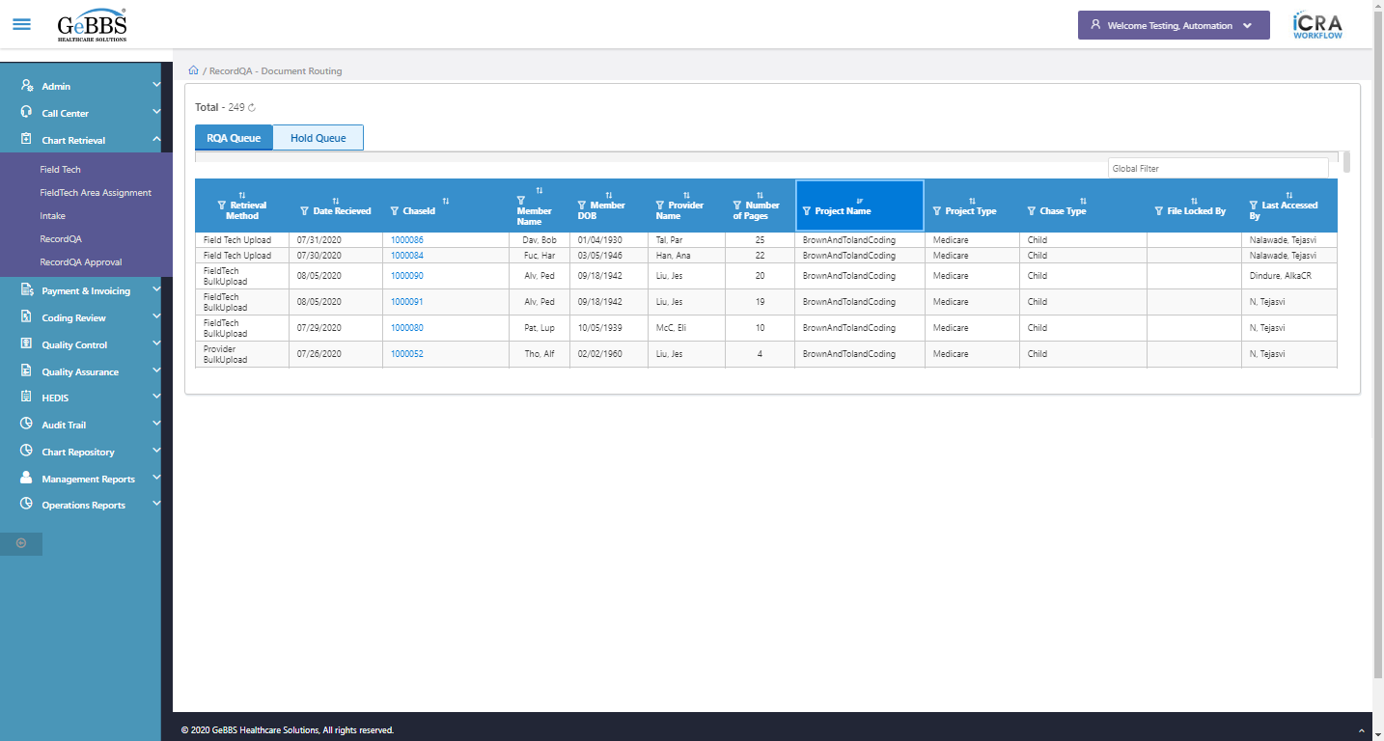  
 Project Type is displayed  
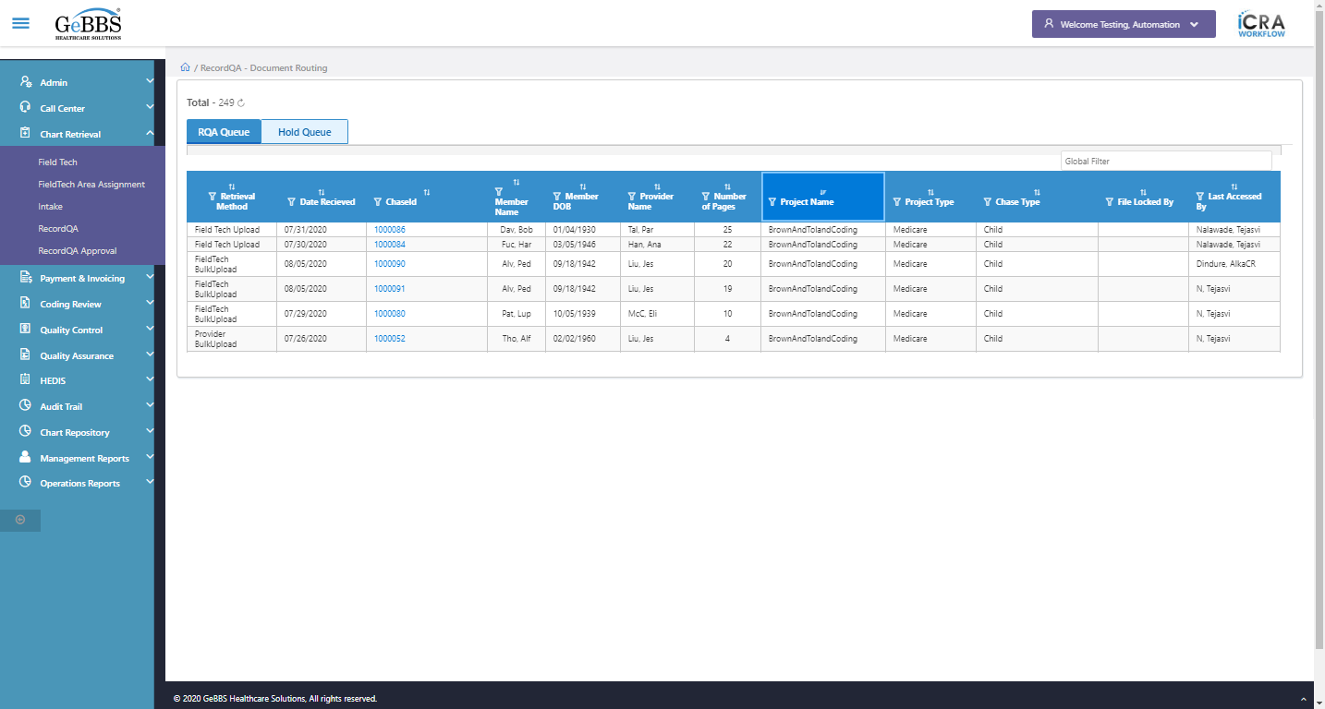  
text is correct  
  
9 th filter is displayed  
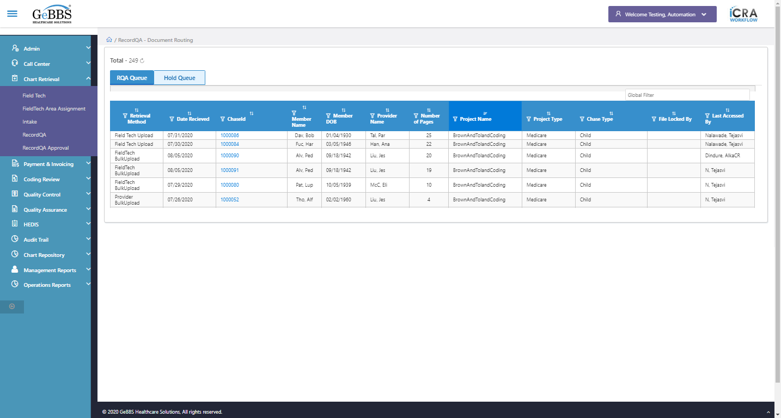  
9 th sorting is displayed  
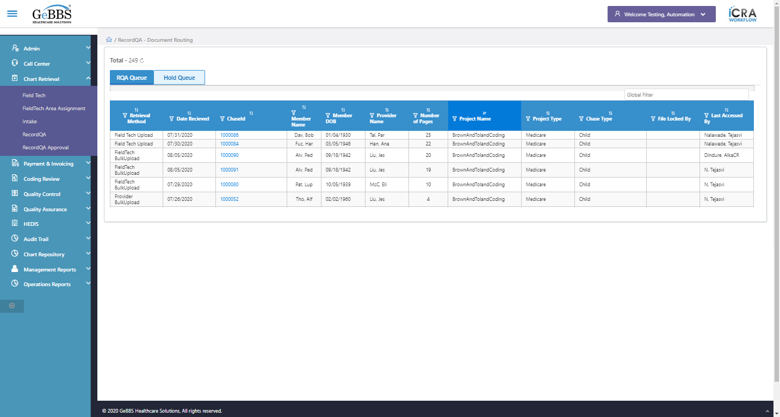  
Sort is clicked  
9 th Asc-sorting is displayed  
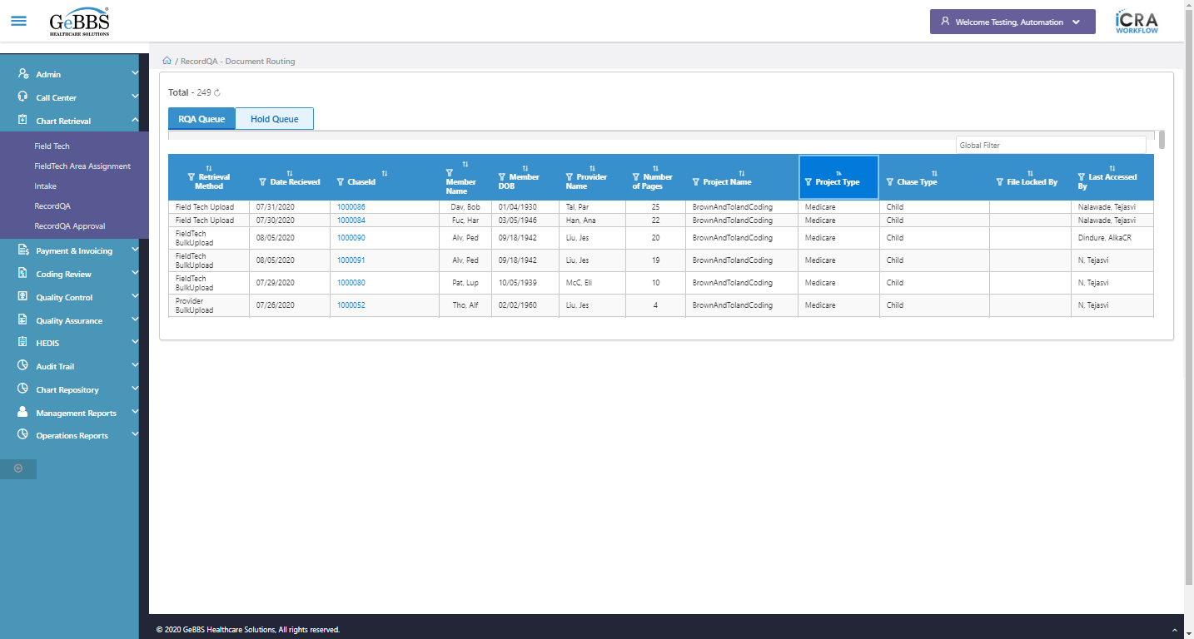  
Sort is clicked  
9 th dsc-sorting is displayed  
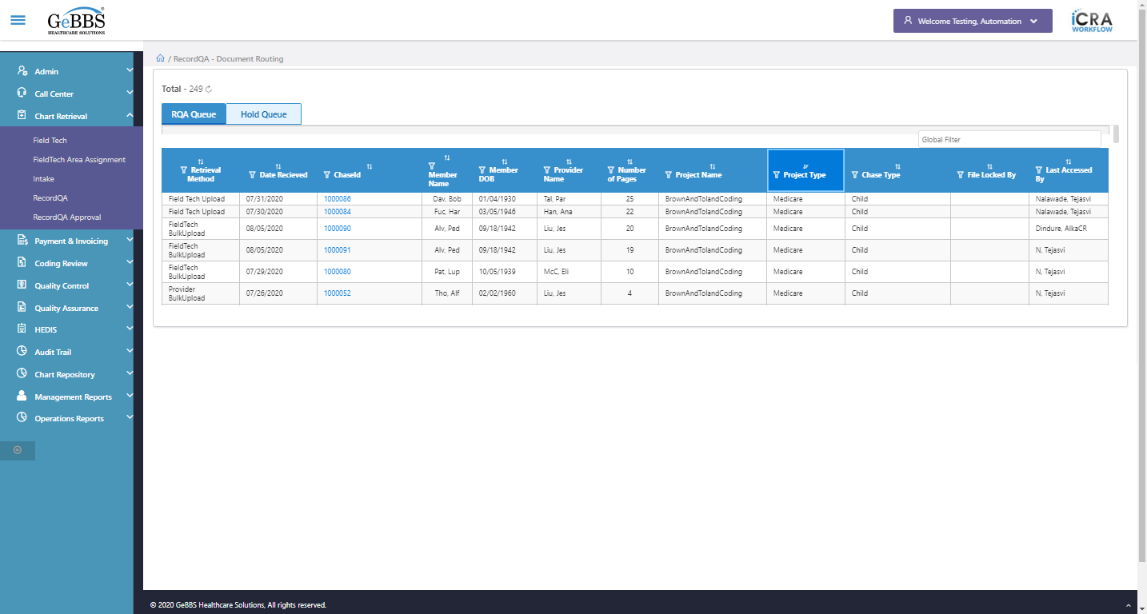  
 Chase Type is displayed  
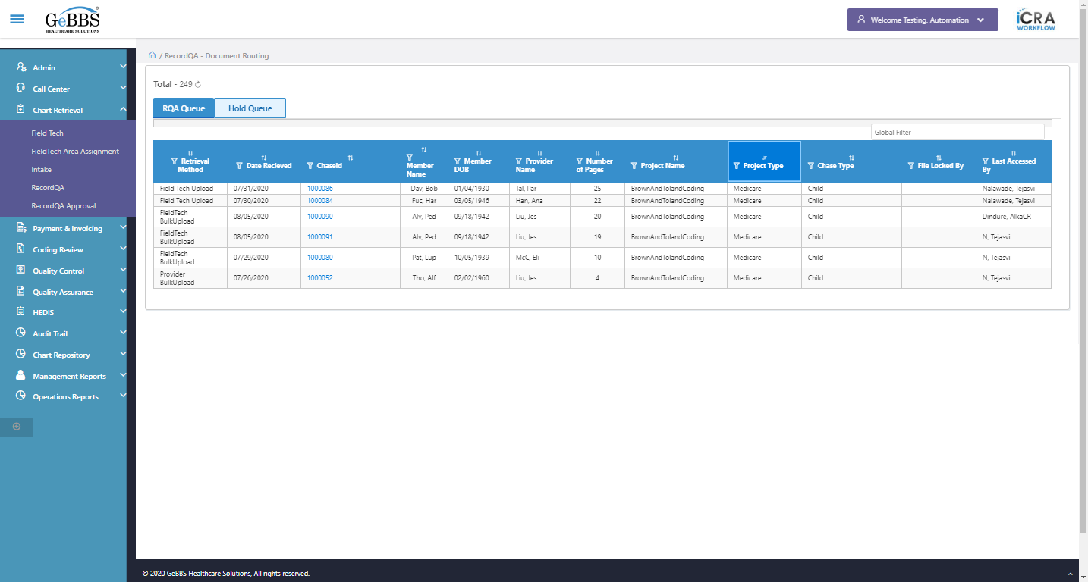  
text is correct  
  
10 th filter is displayed  
  
10 th sorting is displayed  
  
Sort is clicked  
10 th Asc-sorting is displayed  
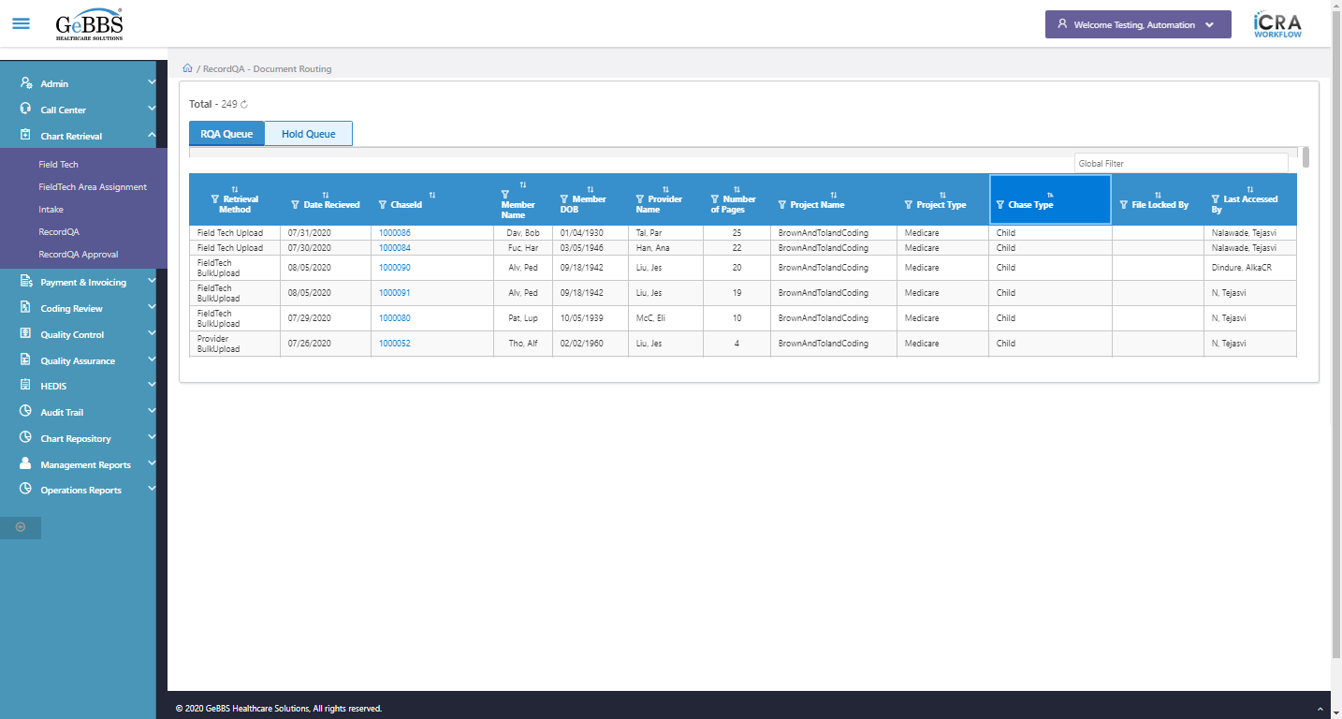  
Sort is clicked  
10 th dsc-sorting is displayed  
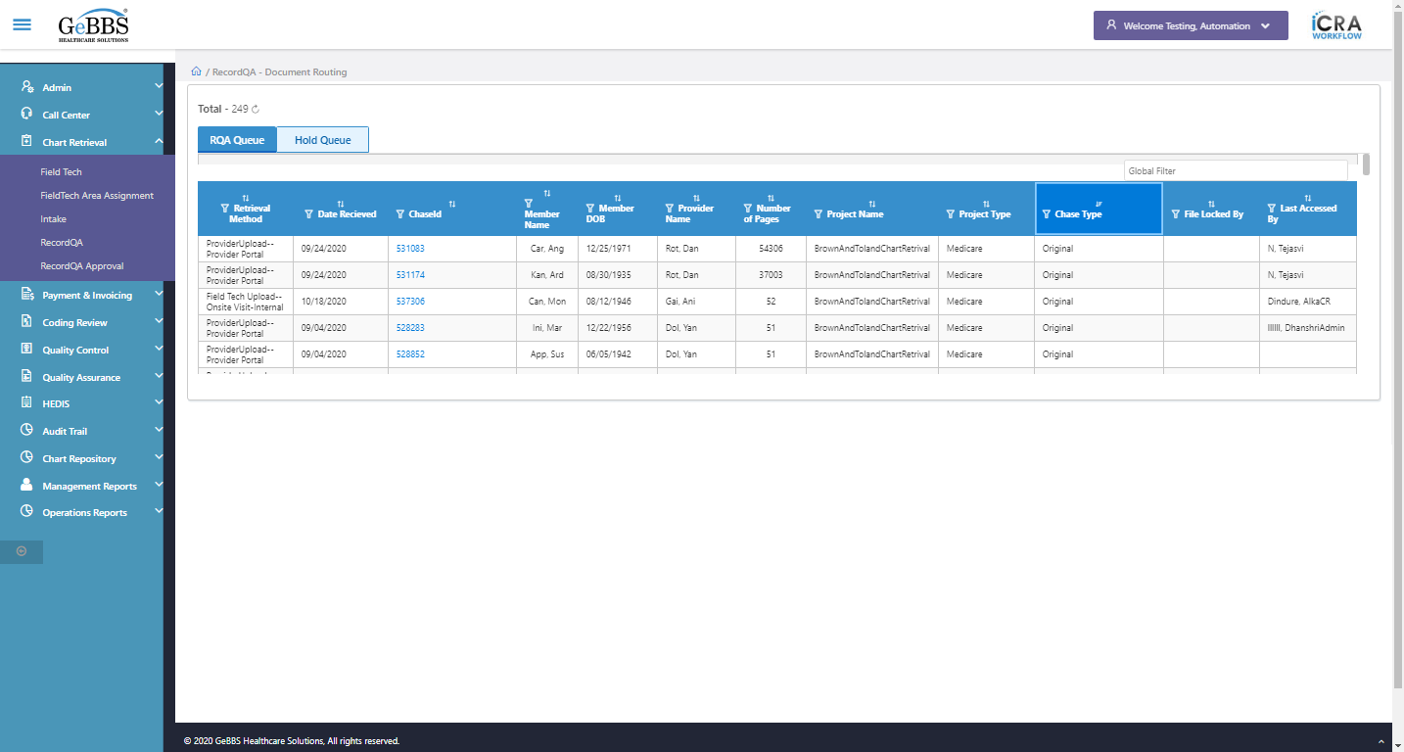  
 File Locked By is displayed  
  
text is correct  
  
11 th filter is displayed  
  
11 th sorting is displayed  
  
Sort is clicked  
11 th Asc-sorting is displayed  
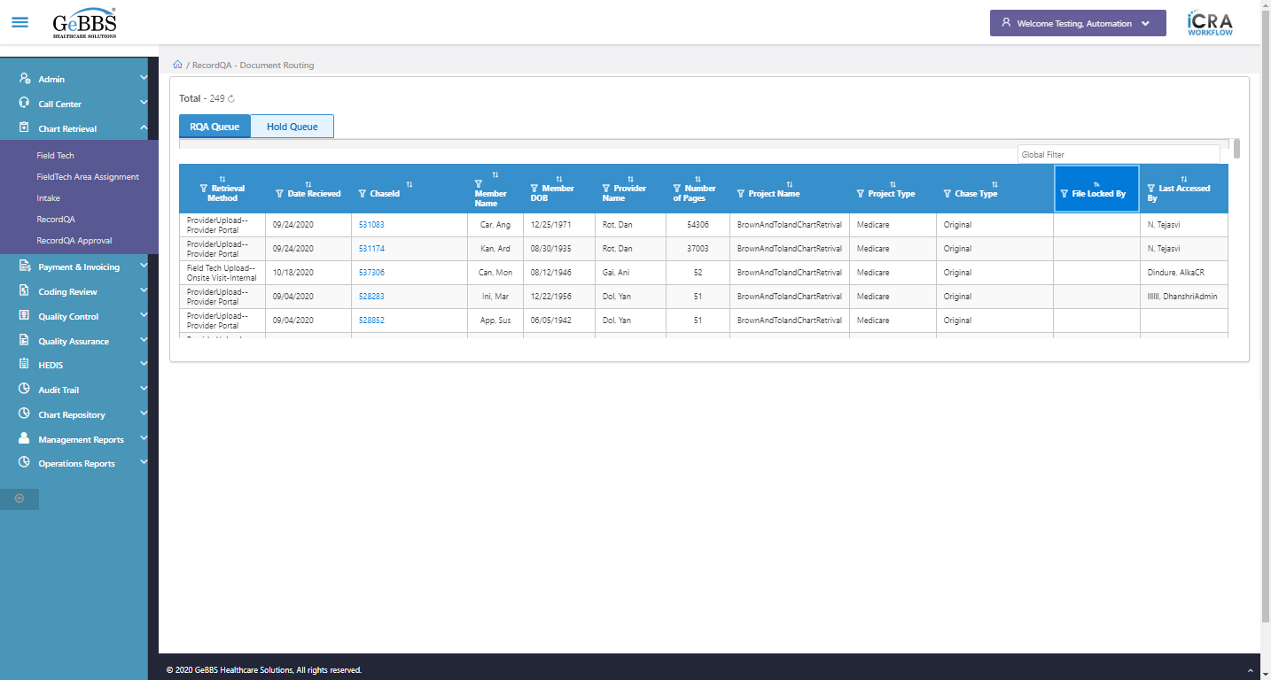  
Sort is clicked  
11 th dsc-sorting is displayed  
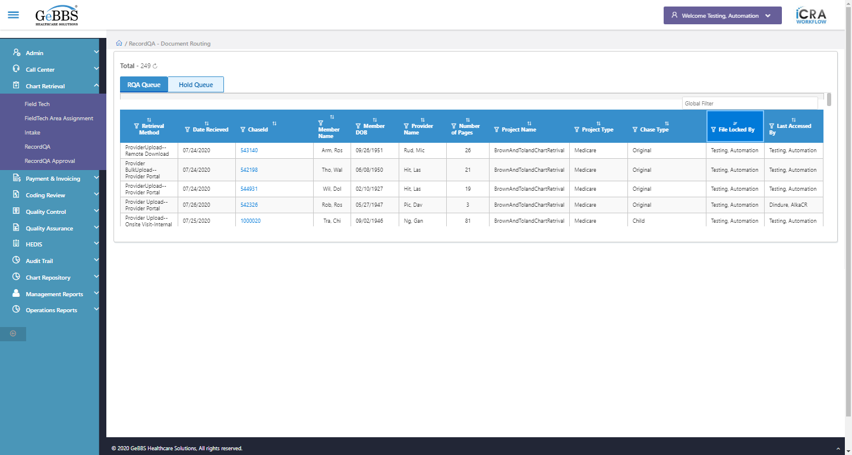  
 Last Accessed By is displayed  
  
text is correct  
  
12 th filter is displayed  
  
12 th sorting is displayed  
  
Sort is clicked  
12 th Asc-sorting is displayed  
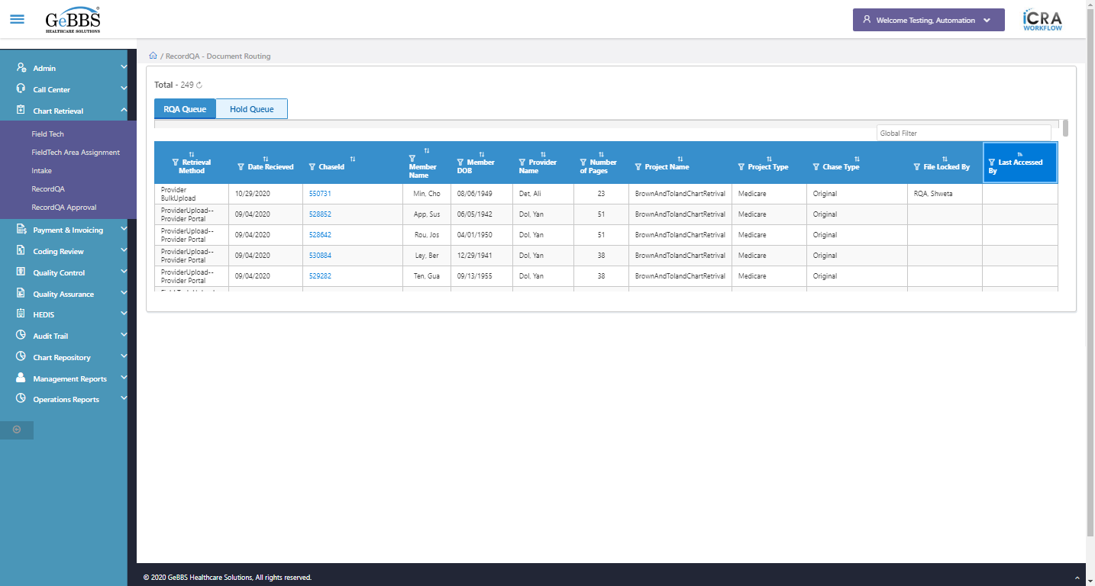  
Sort is clicked  
12 th dsc-sorting is displayed  
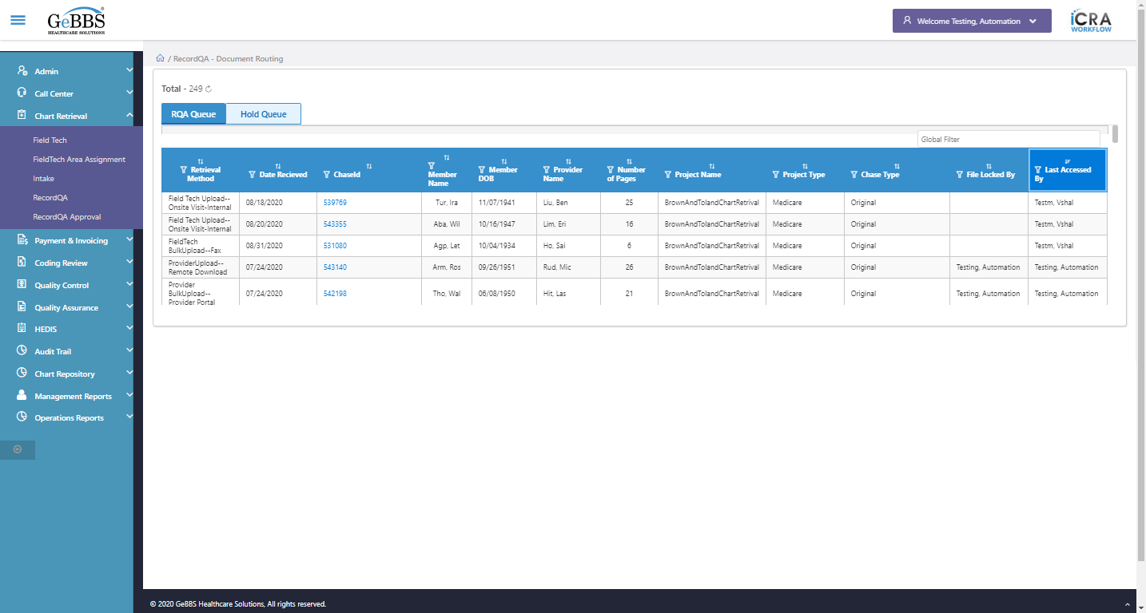  
Scrolled successfully  
Text of the element : 1000010  
GolbalFilter is entered  
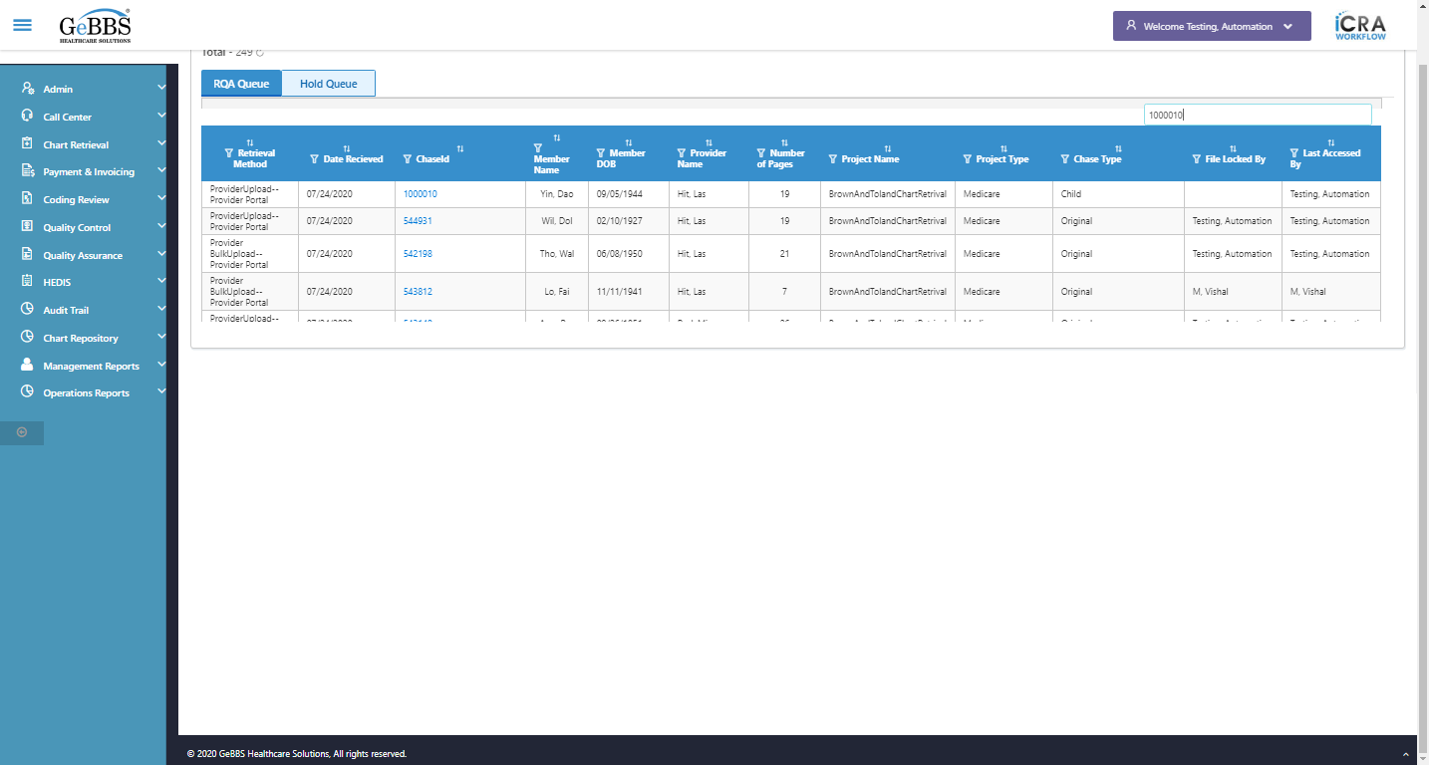  
Text of the element : 19  
Scrolled successfully  
Scrolled successfully  
Scrolled successfully  
Scrolled successfully  
Scrolled successfully  
Scrolled successfully  
Scrolled successfully  
Scrolled successfully  
Scrolled successfully  
Scrolled successfully  
Scrolled successfully  
Scrolled successfully  
Scrolled successfully  
Scrolled successfully  
Scrolled successfully  
Scrolled successfully  
Scrolled successfully  
Scrolled successfully  
Scrolled successfully  
Text of the element : 1000048  
GolbalFilter is entered  
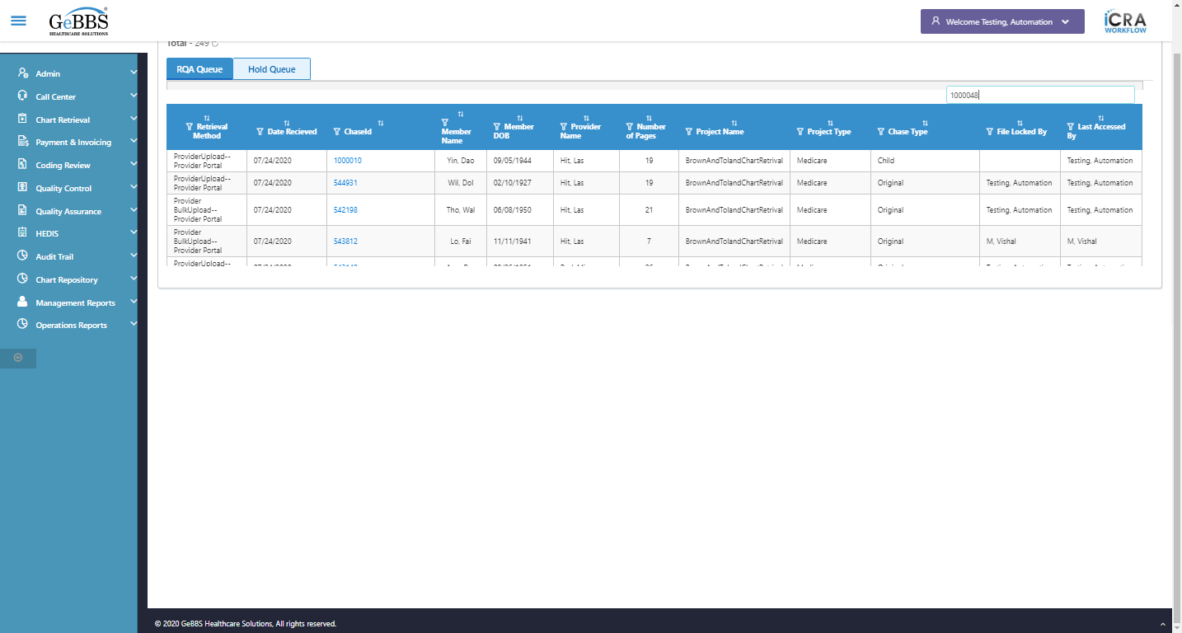  
Text of the element : 2  
The old chase for move or copy:1000010  
Total pages of old chase in grid before move or copy:19  
The new chase for move or copy:1000048  
Total pages of new chase in grid before move or copy:2  
Text of the element : Tho, Alf  
Text of the element : Liu, Jes  
GolbalFilter is entered  
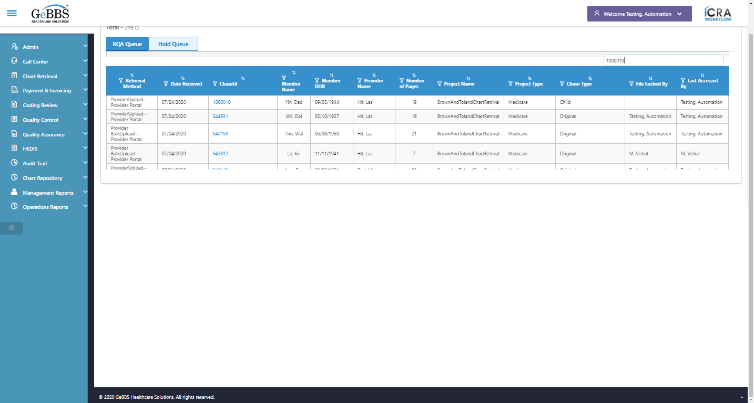  
chaseid is clicked  
Frame found and switched to   
PDF File is present   
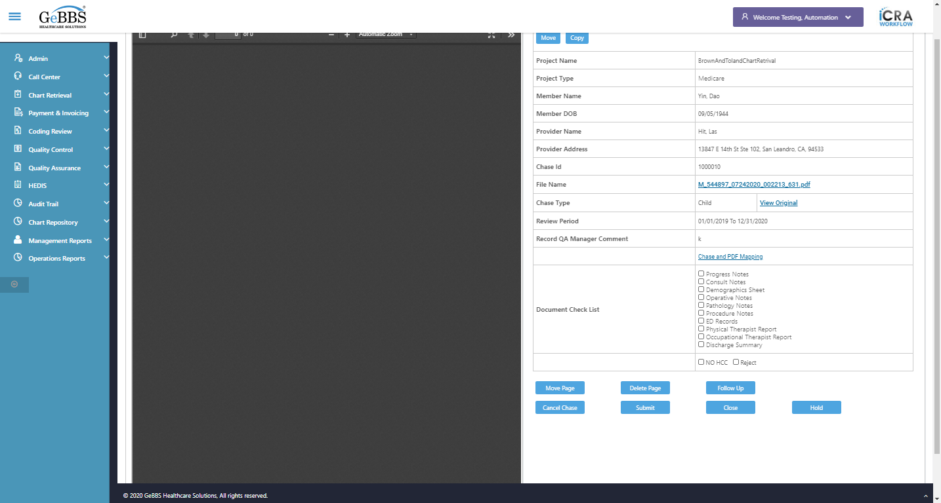  
Attribute for max is : 21  
Move is clicked  
Close_MoveWindow is clicked  
Move is displayed  
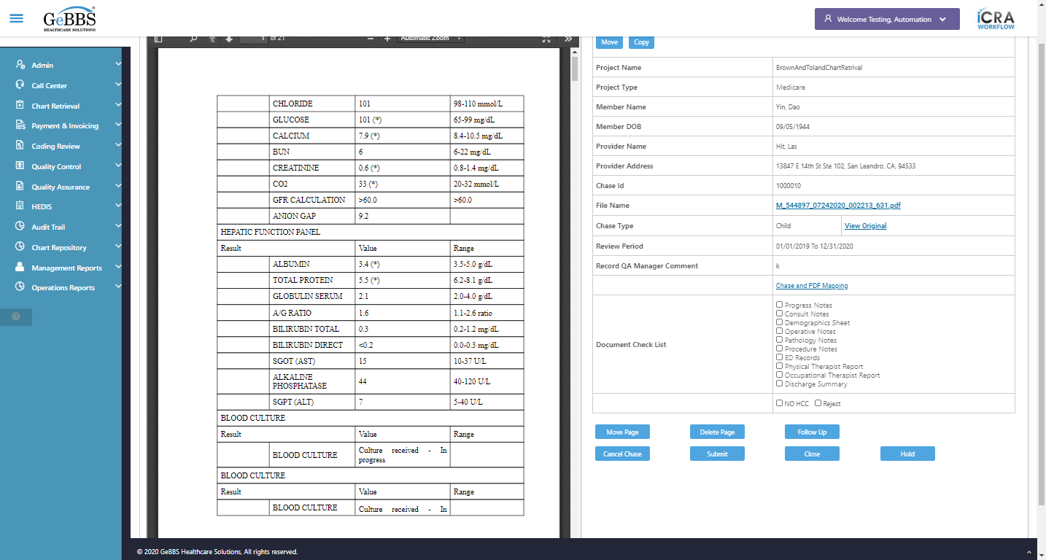  
Chked After Cliking Close button user is navigated to PDF detail screen or not  
Move is clicked  
FromPage is displayed  
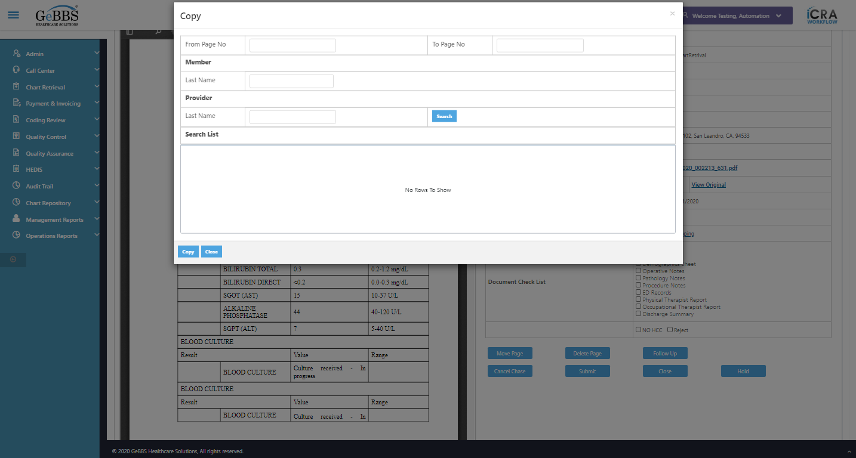  
ToPage is displayed  
  
MemberLastName is displayed  
  
ProviderLastName is displayed  
  
Search_MoveWindow is displayed  
  
Move_MoveWindow is displayed  
  
Close_MoveWindow is displayed  
  
GridPanel is displayed  
  
Move_MoveWindow is clicked  
Message is displayed  
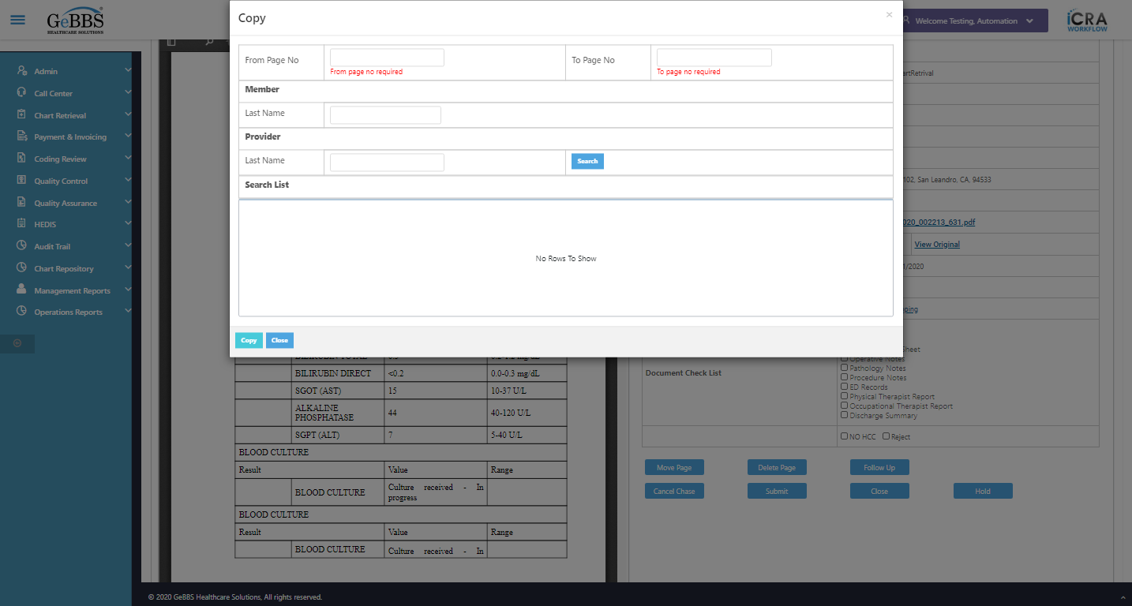  
From page error message is correct  
  
Message is displayed  
  
To page error message is correct  
  
Search_MoveWindow is clicked  
Message is displayed  
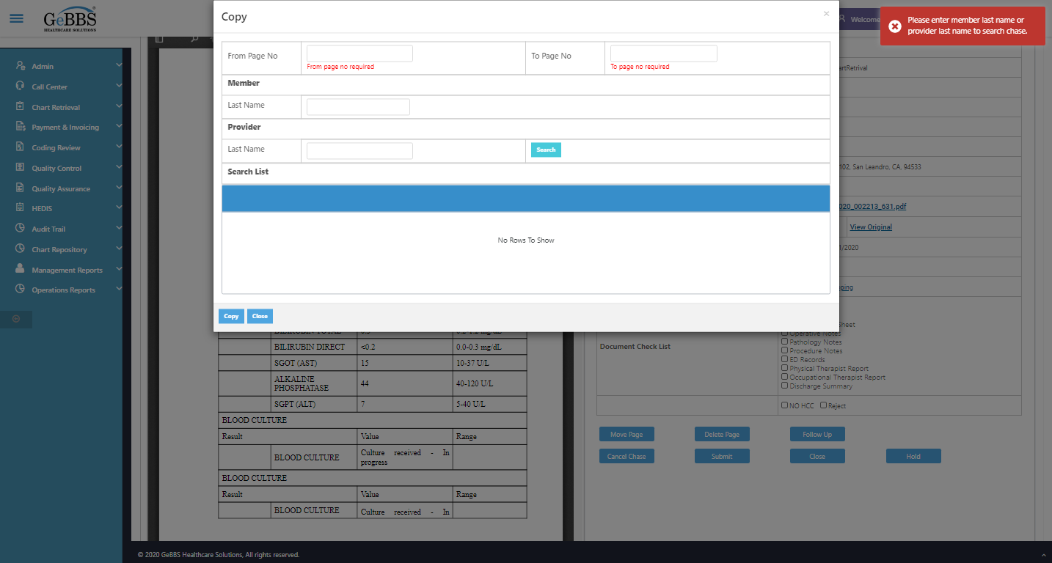  
Alert message is correct  
  
FromPage is entered  
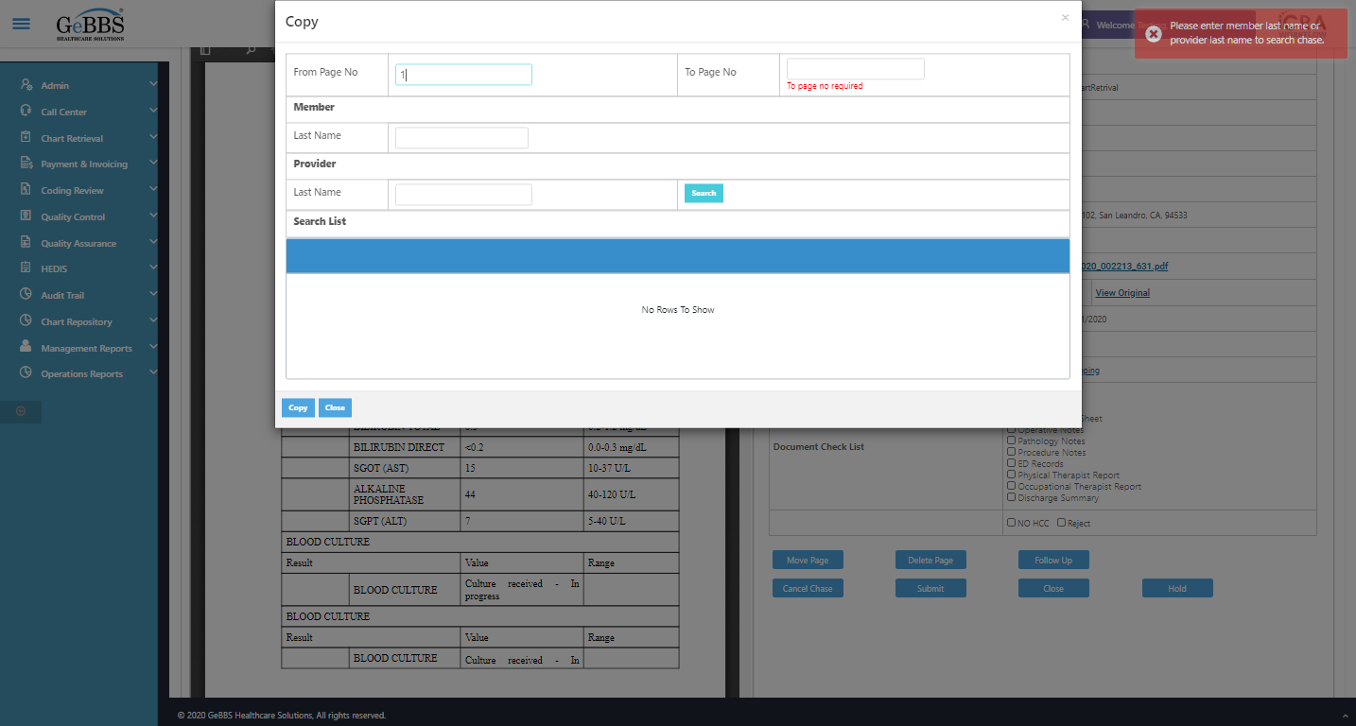  
ToPage is entered  
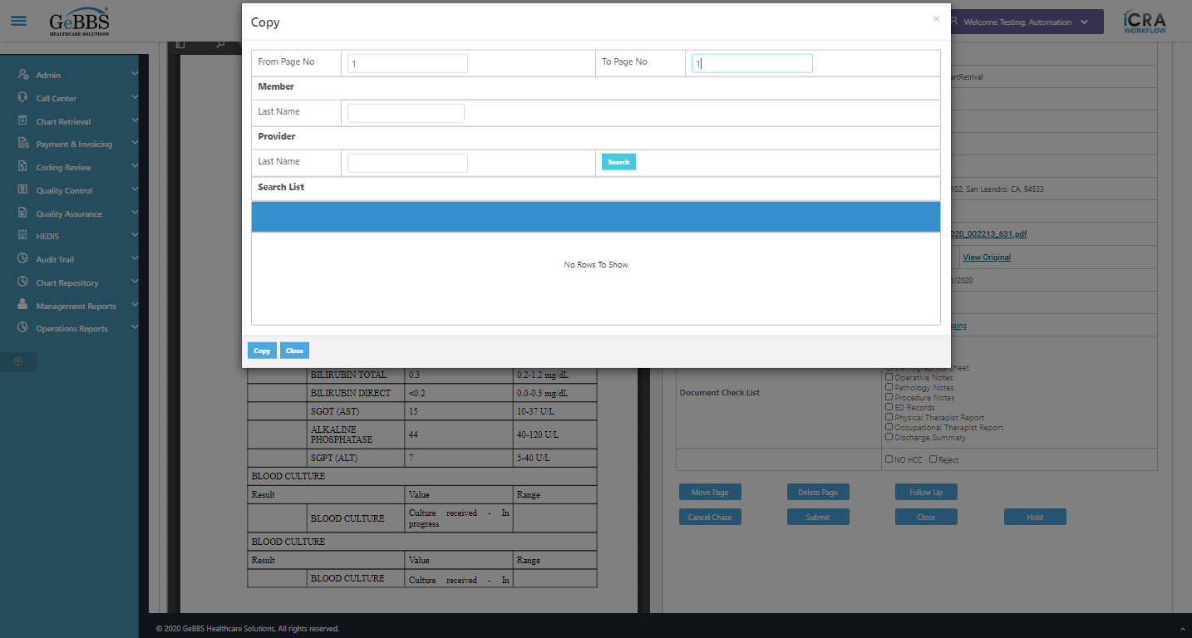  
MLastName is entered  
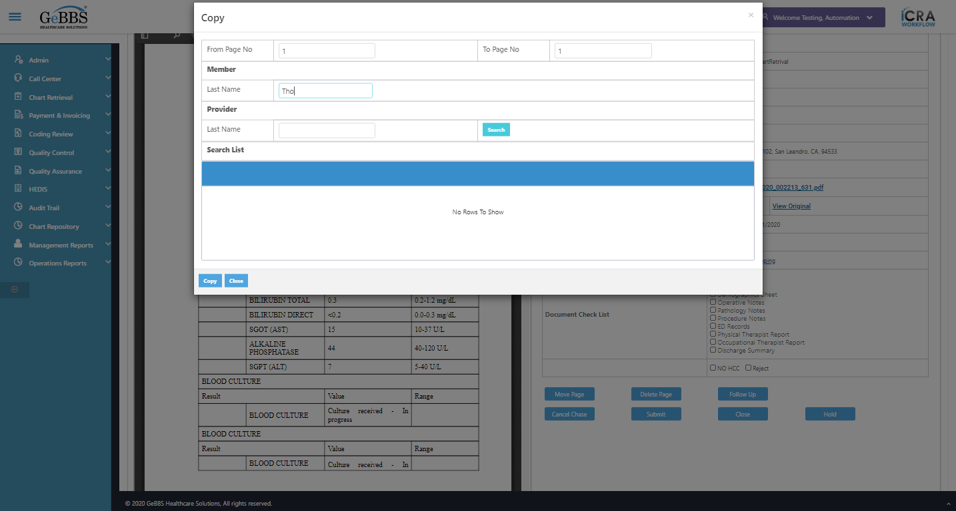  
PlastName is entered  
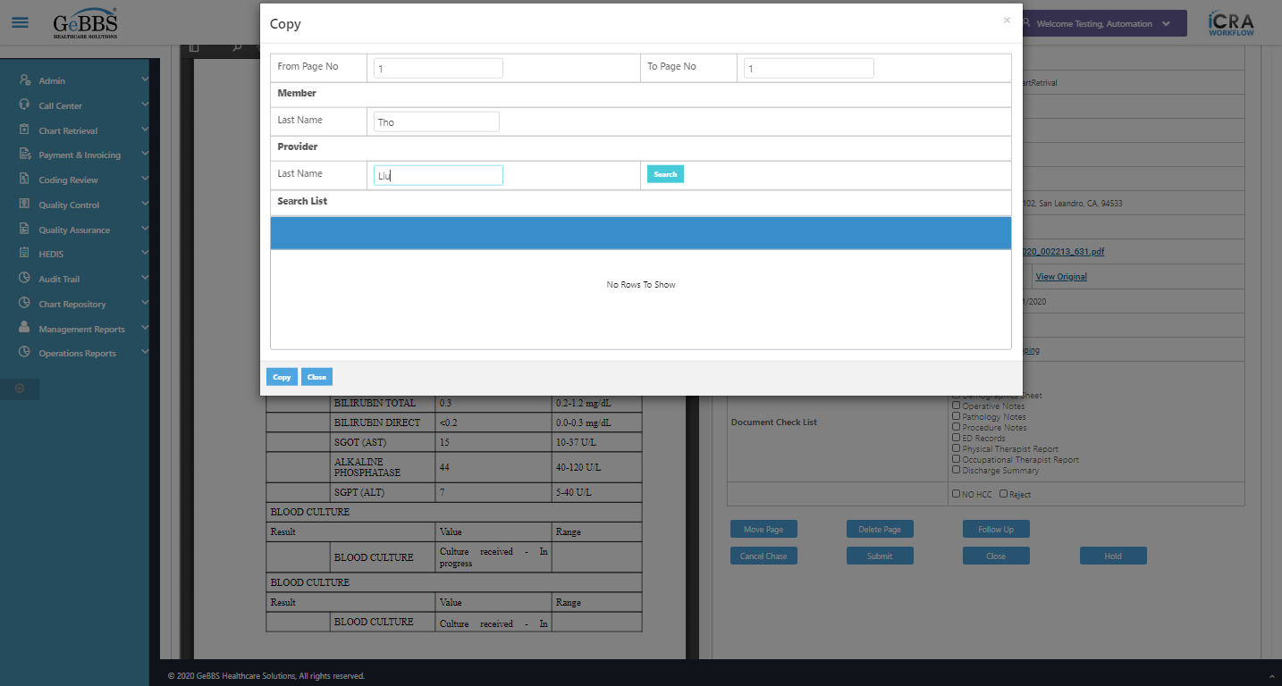  
Search_MoveWindow is clicked  
Move_MoveWindow is clicked  
Message is displayed  
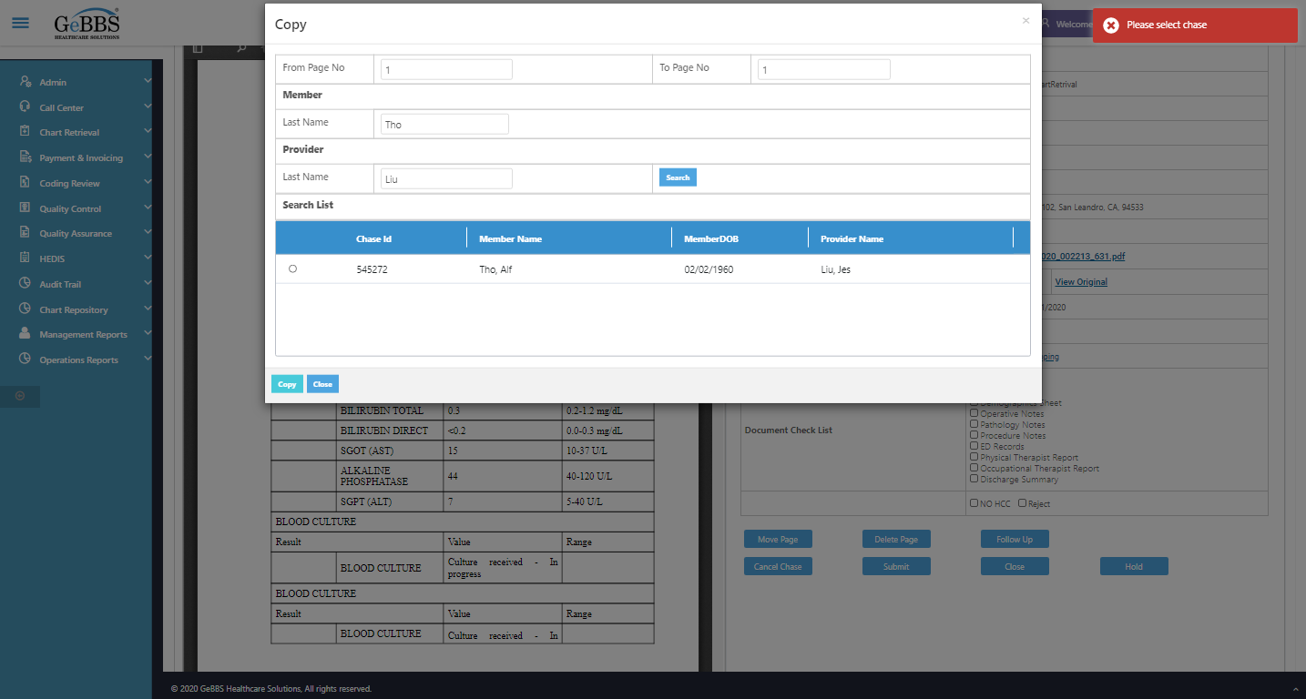  
AlertMsg_MoveWindow is correct  
  
Filled all data  
Move is clicked  
MoveCopySuccess msg correct  
  
Clicked move and checked alert  
Expected condition failed: waiting for visibility of Proxy element for: DefaultElementLocator 'By.xpath: //div[@class='toolbar']//input[@id='pageNumber']' (tried for 5 second(s) with 500 milliseconds interval)  
